|  |  |
| --- | --- |
| *Pacific Gas and Electric Company* | |
| Patch 7.6.3 Installation Guide | |
|  |  |
|  |  |
| Project | ED AM/GIS |
|  |  |
| Prepared by | Ashish Narasimham |
| Date | 8/29/2013 |
| Version | 1.0 |
| Version Type | Final |

|  |  |  |  |
| --- | --- | --- | --- |
| Revision History | | | |
| Document # | Date | Author | Summary of Changes |
| 1.0 | 8/28/13 | Ashish Narasimham | Initial Document Creation |

# Introduction

## Purpose

This document is intended to detail the implementation and configuration steps required to implement Patch 7.6.3 Installation Guide. This document describes the various configuration aspects required to complete any manual or automatic patch associated with this release. Each section in this document contains the steps required to patch the system in production.

## Terms Used

|  |  |
| --- | --- |
| OOTB | Out of the box. Unmodified from the commercial version. |
| TFS | Team Foundation Server |

## External Documents

Referenced are any external configuration documents or exports. These are documents that contain more detailed information about configuring a system or documents that can be loaded into an application to perform the configuration detailed in this document.

### Connectivity Rules XML file

### Location: \\sfetgis-nas01\sfgispoc_data\ApplicationDevelopment\IBM_TeamMembers\AshishNarasimham

### Filename: ConnectivityRulesUpdated_Prod_rel_3.xml

## Summary of Steps to Complete Patch

These are the high-level steps to complete the installation and configuration of the data model patch. Use this table as a guide for completing the installation. Links are provided that can lead either within the document for detailed explanations or to external sites such as Sharepoint.

|  |  |  |  |
| --- | --- | --- | --- |
|  | **Step Name** | **Description** | **CR (if applicable)** |
|  | Master For Data Model Release X.X.X |  |  |
|  | Open a Database Connection | Open a database connection in ArcCatalog | - |
|  | Add Connectivity Rules | Connectivity rule changes approved by Robert while working with Ryan Bae this week will be imported via XML | [9678](http://edappgistfsprd1:8080/tfs/ElectricDistCollection/EDAMGIS/_workItems#_a=edit&id=9678) |
|  | Correct the EDGIS.SupportStruct_SpecialConditions labeling. | Relationship needs to be rebuilt to show the forward label as Special Conditions and backward as Support Structure | [9618](http://edappgistfsprd1:8080/tfs/ElectricDistCollection/EDAMGIS/_workItems#_a=edit&id=9618) |
|  | Update Data Model Version Table | Update the data model version table to reflect this update | - |

# Open a Database Connection in ArcCatalog

1. Open ArcCatalog.
2. Within the Catalog Tree, expand “Database Connections” and open the active connection for this process. This is the connection that is referenced in the change request associated with this document (EDGIS<DB name in the format X#Y> )

# Add Connectivity Rules

Import an XML configuration into the database to update connectivity rules

Before performing this step, please ensure that you have the connectivity rules patch (originating from Vinay) installed locally. Without this, performing this step will break the system.

1. Open the Geodatabase Designer toolbar in ArcCatalog.
2. Click the Output Window button on the toolbar to view the Output Window. 
3. Click the XML tab and click Open.  
   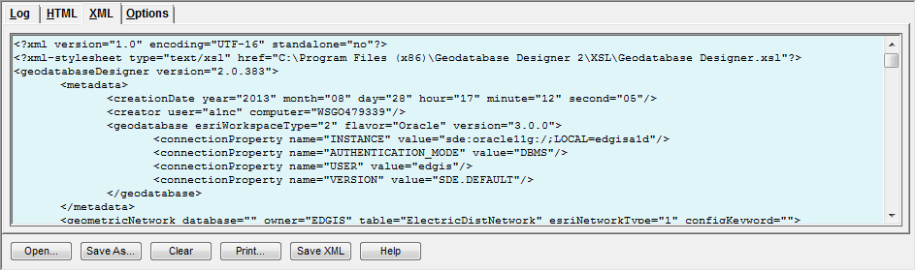
4. Copy/paste the filepath referenced in Section 1.3 of this document (titled External Documents) into the File Explorer window and select the Connectivity file in that folder (name referenced in Section 1.3 of this document).

1. Select the drop down on the toolbar of “Import Schema” ->Import From XML from the Designer toolbar to start the process. The streaming output will appear in the Log tab. When it displays some form of the following sentence, you are done:



# Correct the EDGIS.SupportStruct_SpecialConditions labeling

1. At the root level, select the SupportStruct_SpecialConditions relationship, right click, and select Delete.  
   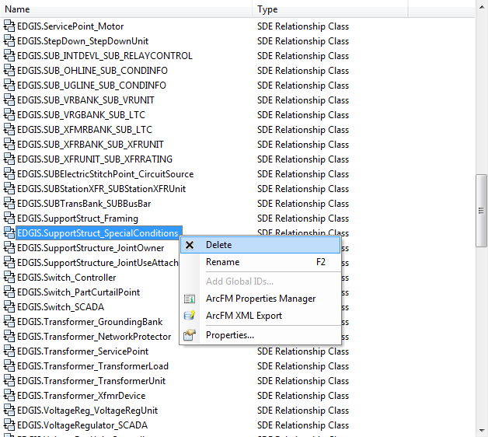
2. Right click in the empty area and select New->Relationship Class. Proceed through the screens, matching the screenshots below:
   1. Name: SupportStruct_SpecialConditions
   2. Origins: ElectricDataset -> SupportStructure
   3. Dest: Root -> SpecialConditions

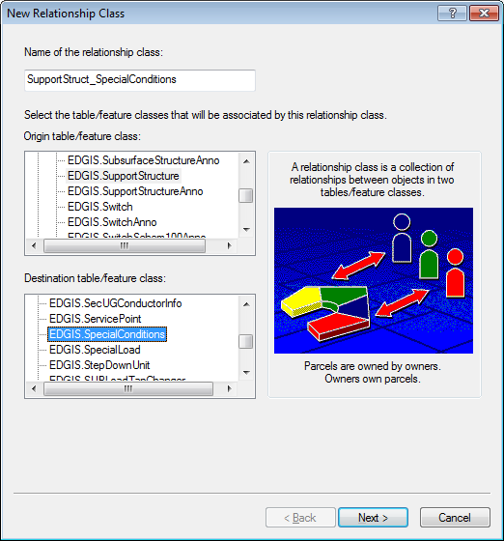

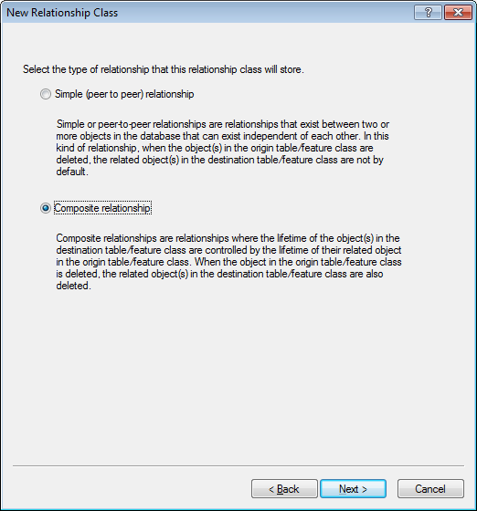

Forward Label: Special Conditions

Reverse Label: Support Structure

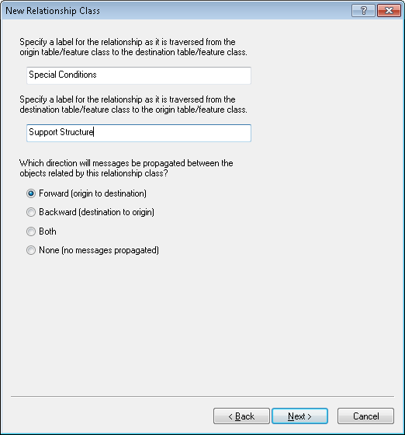

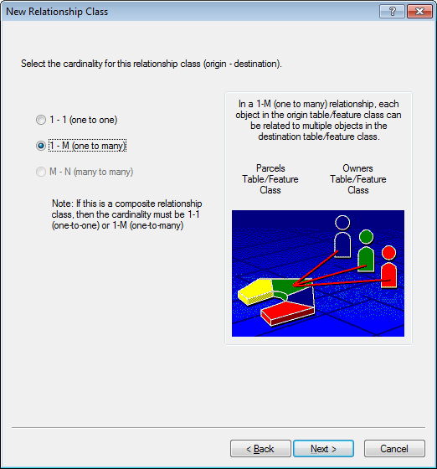

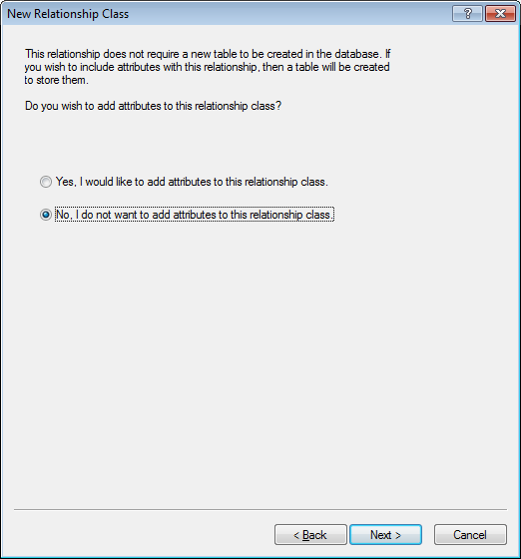

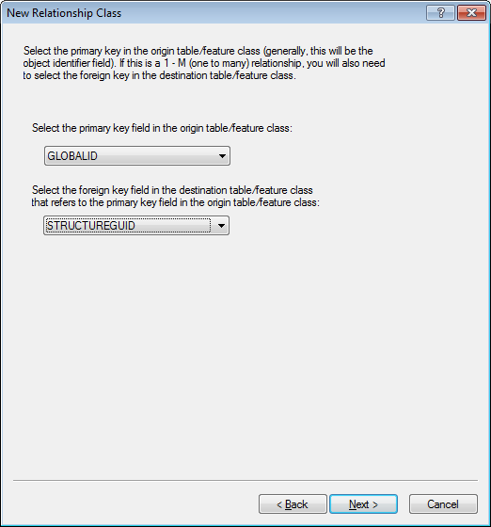

Compare the new relationship against this summary page:

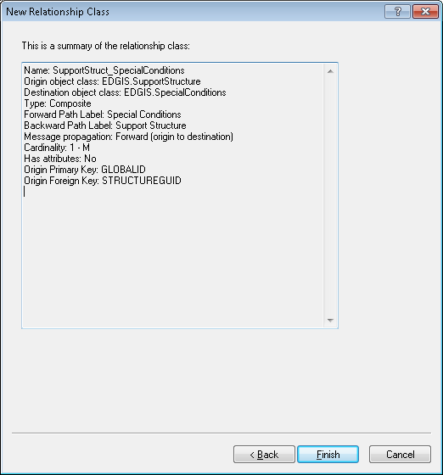

# Update Data Model Version Table

**Database Configuration:**

1. Open SQL Plus.
2. Log in using the same server and user as was used in section 2.  
     
   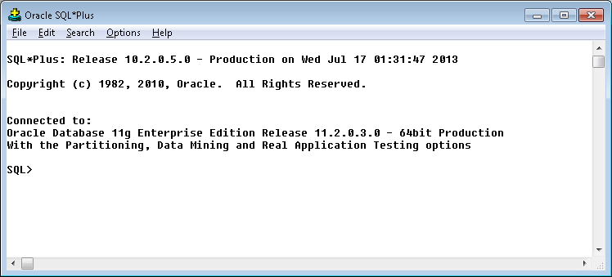
3. Run the SQL below AFTER replacing the <INSERT TEAM MEMBER DONE BY> with your username.

update pgedatamodelversion set currentidc='N' where currentidc='Y';

insert into pgedatamodelversion (OBJECTID, CURRENTIDC, DATEAPPLIED, APPLIEDBYPERSONNAME, MODELVERSION) values (**35**,'Y',sysdate,'**<INSERT TEAM MEMBER DONE BY>**','**7.6.3 GOLD** **CR9627**');

# Known Issues

<Please List any other issues encountered here while following the document>